**Students**

1. **Create Student**
   * **Method:** POST
   * **Endpoint:** /student
   * 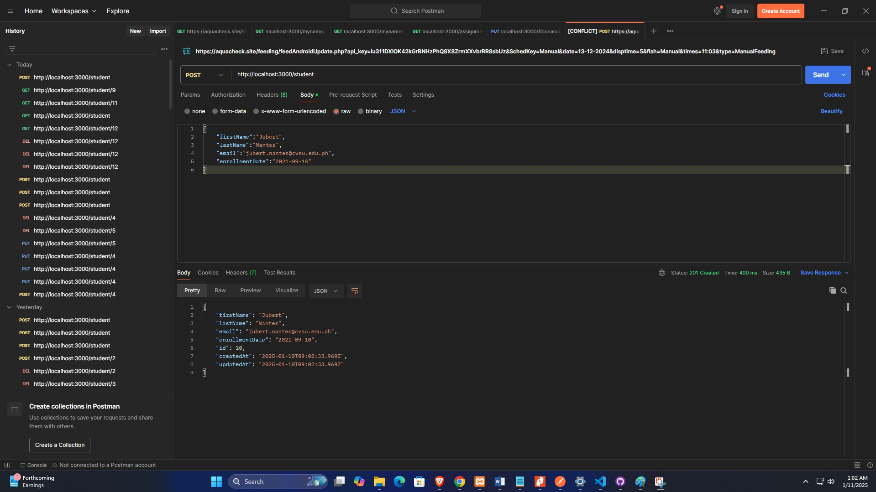**Request Body:**

**Response:**

* **Status:** 201 Created
* **Body:**



1. **Read Student (Get All)**
   * **Method:** GET
   * **Endpoint:** /student
   * 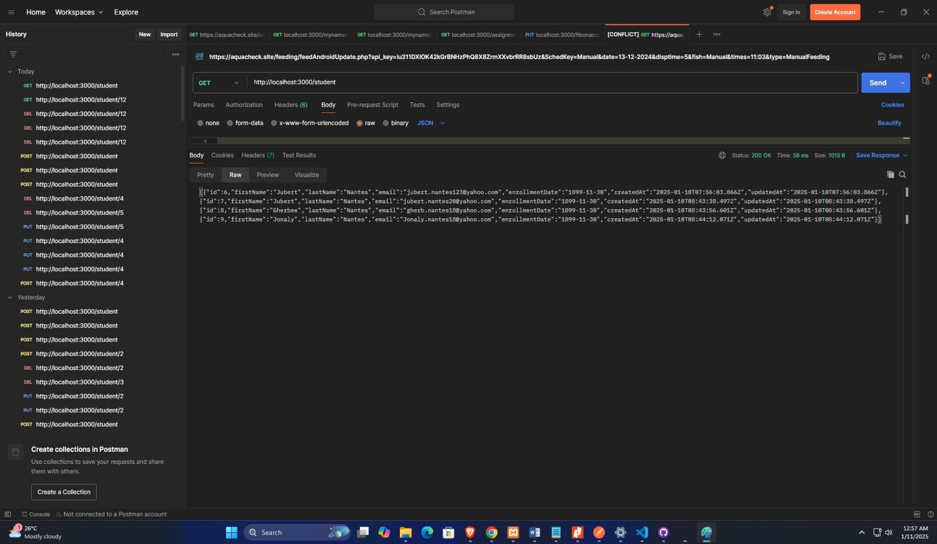**Request Body:** 200 OK
2. **Read Student (Get One)**
   * **Method:** GET
   * **Endpoint:** /student/9
   * 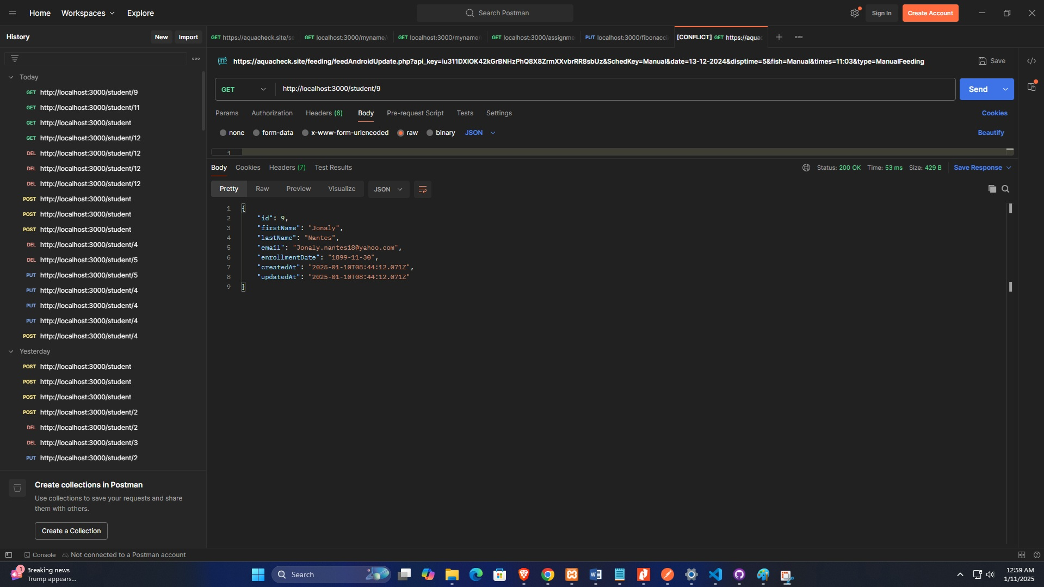**Request Body:** 200 OK
3. **Update Student**
   * **Method:** PUT
   * **Endpoint:** /student/10
   * **Request Body:**

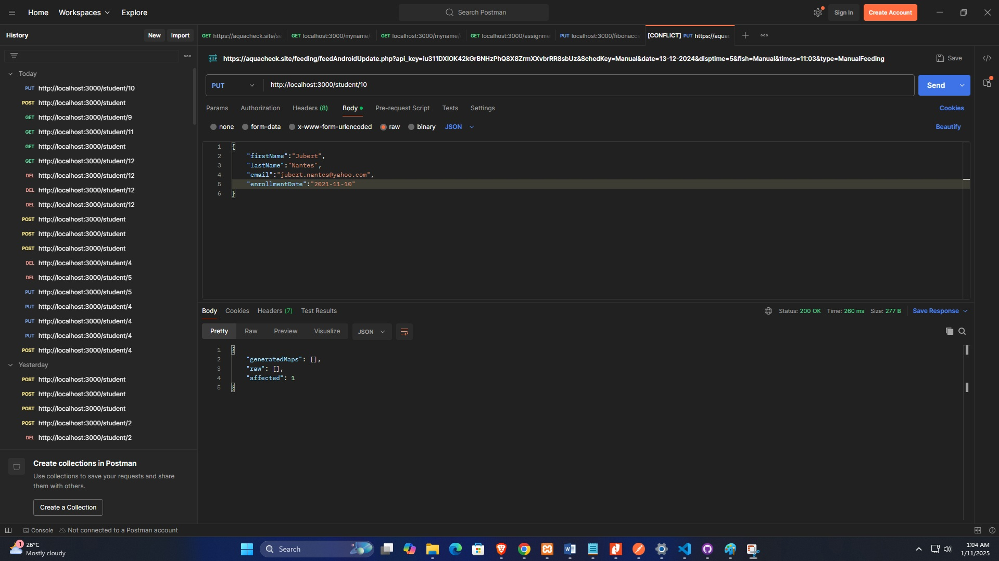

**Response:**

* **Status:** 200 OK
* **Body:**

1. **Delete Student**
   * **Method:** DELETE
   * **Endpoint:** /student/9
   * 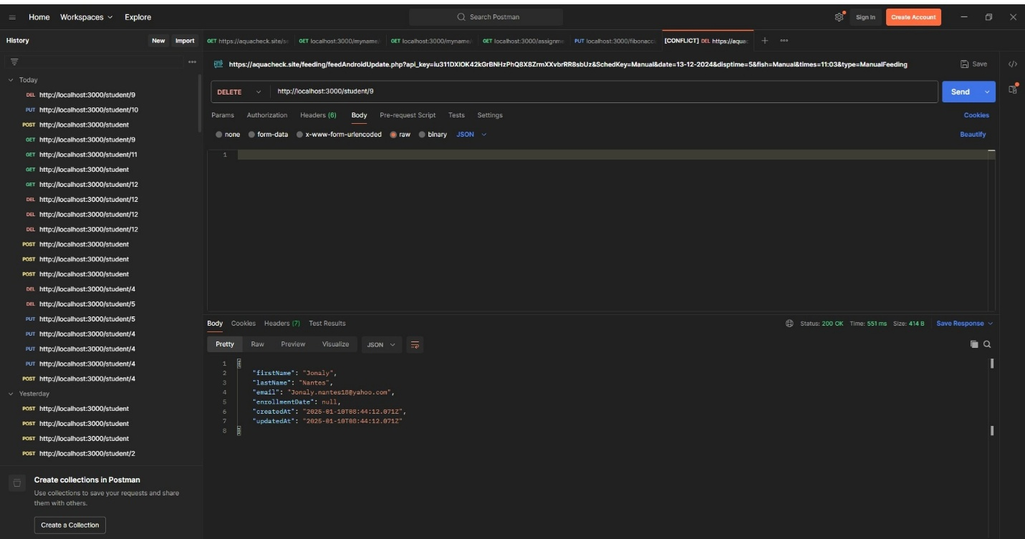**Request Body:**